Exhibition Application Form and Contract

Please complete by email/post to:
A/C Ms. Catarina Cunha
fib ICCS2024
ISISE – Institute for Sustainability and Innovation in Structural Engineering
University of Minho, School of Engineering
Campus de Azurém
4800-058 Guimarães, Portugal

Email: fibiccs24@civil.uminho.pt
Web: https://fibiccs.org/

Data of the Company:
Company Name: | Click or tap here to enter text.
Company VAT number: | Click or tap here to enter text.
Contact name: | Click or tap here to enter text.
Address: | Click or tap here to enter text.
Postal Code: | Click or tap here to enter text.
City: | Click or tap here to enter text.
Country: | Click or tap here to enter text.
Mobile phone: | Click or tap here to enter text.
Email: | Click or tap here to enter text.
Website: | Click or tap here to enter text.

We wish to book the following booth type:
☐ | Booth 2 x 3 m² until March 31, 2024 (2,500 €) – 2 to 13 (see layout in the last page)
☐ | Booth 2 x 3 m² after March 31, 2024 (3,000 €) – 2 to 13 (see layout in the last page)
☐ | Booth 1 x 3 m² until March 31, 2024 (1,500 €) – 15 to 29 (see layout in the last page)
☐ | Booth 1 x 3 m² after March 31, 2024 (2,000 €) – 15 to 29 (see layout in the last page)
Preferable booth (see the layout in the last page): Click or tap here to enter text.
The fee includes:
- One general delegate registration. Activities with additional charges are excluded.
- Listing on the conference website and in the final programme.
- The exhibition space includes one table, one chair and access to electricity.
Observations:
Click or tap here to enter text.
Click or tap here to enter text.
Click or tap here to enter text.

Reservation:
- All amounts/fees must be paid in Euros;
- Exhibition and sponsorship fees will be billed for at 50% at the time of booking (for bookings made before March 31, 2024);
- Send always the proof of payment to fibiccs24@civil.uminho.pt, together with this form;
- The remainder of the value (50%) must be paid until March 31, 2024. Non-payment is subject to cancellation of booking without reimbursement of the deposit paid;
- The bookings made after March 31, 2024, will be billed for the total amount. The total amount must be paid 30 days before the Conference;
- Setting up of exhibition booths will NOT be allowed if payment is not previously confirmed;
- The amount is subject to prevailing taxes at the time of booking, namely the Value Added Tax (VAT), if applicable.

Payment (by bank transfer):
Bank: Caixa Geral de Depósitos
Account Name: Quality Tours Global Services
IBAN: PT50 0035 0860 0001 6669 9304 5
BIC/Swift: CGDIPTPL

Cancellation policy:
All cancellations and changes to the original booking must be made in writing to the Conference Organiser Secretariat. The cancellation fees are:
- 25% of the amount if the cancellation is received within 6 months before the Conference.
- 50% of the amount if the cancellation is received 3 - 6 months before the Conference.
- 75% of the amount if the cancellation is received 1 - 3 months before the Conference.
- No refund if the cancellation is received within 30 days before the Conference.

Place and Date: Click or tap here to enter text.

Signature and company stamp:
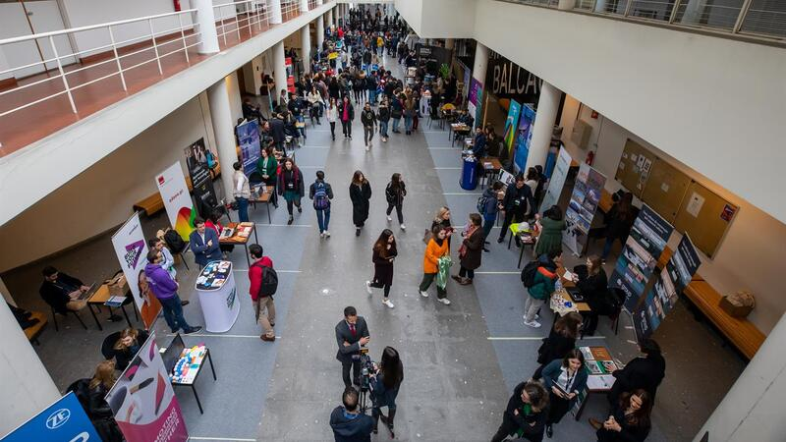 | 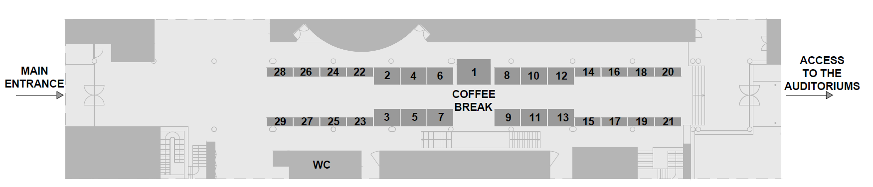
Layout of the Exhibition (tentative)

